Experiment 6: Implement List Methods (Add, Append, Extend and Delete)
Aim: To write a Python program to implement list methods such as add, append, extend and delete.
Algorithm:
- Start the program.
- Create a list of elements.
- Add an element using insert().
- Append an element using append().
- Extend the list using extend().
- Delete an element using del.
- Display the list after each operation.
- Stop the program.
Code:
numbers = [10, 20, 30]
print("Original List:", numbers)
numbers.insert(1, 15)
print("After Add:", numbers)
numbers.append(40)
print("After Append:", numbers)
numbers.extend([50, 60])
print("After Extend:", numbers)
del numbers[2]
print("After Delete:", numbers)

Output:
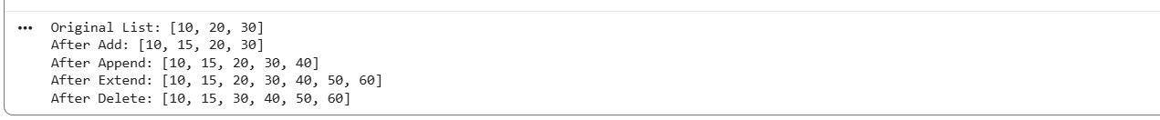
Result: Thus, the Python program to implement list methods was executed successfully.

Experiment 7: Illustrate Different Set Operations
Aim: To write a Python program to demonstrate different set operations.
Algorithm:
- Start the program.
- Initialize two sets.
- Perform union of the sets.
- Perform intersection of the sets.
- Find the difference between the sets.
- Find the symmetric difference.
- Display all results.
- Stop the program.
Code:
A = {1, 2, 3, 4}
B = {3, 4, 5, 6}
print("Set A:", A)
print("Set B:", B)
print("Union:", A | B)
print("Intersection:", A & B)
print("Difference A-B:", A - B)
print("Difference B-A:", B - A)
print("Symmetric Difference:", A ^ B)
Output:
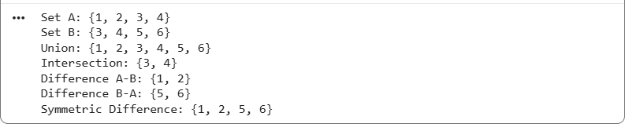
Result: Thus, the Python program to demonstrate different set operations was executed successfully.
Experiment 8: Generate Calendar for the Given Month and Year
Aim: To write a Python program to display the calendar for a given month and year.
Algorithm:
- Start the program.
- Import the calendar module.
- Read the year and month from the user.
- Generate the calendar using calendar.month().
- Display the calendar.
- Stop the program.
Code:
import calendar
year = int(input("Enter year: "))
month = int(input("Enter month (1-12): "))
print(calendar.month(year, month))

Output:
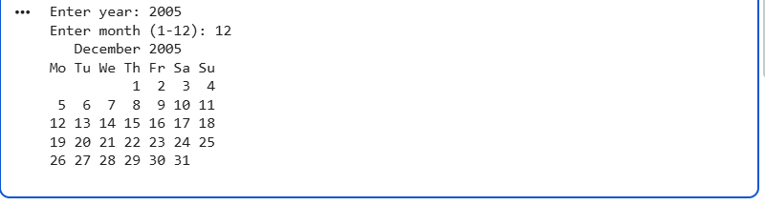
Result:
Thus, the Python program to generate a calendar for a given month and year was executed successfully.
Experiment 9: Remove Punctuations from a Given String
Aim: To write a Python program to remove punctuation marks from a given string.
Algorithm:
- Start the program.
- Import the string module.
- Read a string from the user.
- Create a string containing punctuation marks.
- Remove punctuation using a loop or string replacement.
- Display the resulting string.
- Stop the program.
Code:
import string
text = input("Enter a string: ")
result = ""
for ch in text:
if ch not in string.punctuation:
result += ch
print("String without punctuation:", result)
Output:
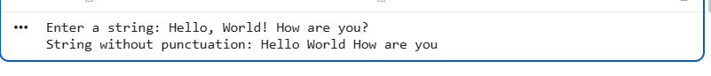
Result: Thus, the Python program to remove punctuation marks from a given string was executed successfully.
Experiment 10: Solve the 8-Puzzle Problem
Aim: To write a Python program to solve the 8-puzzle problem using the A* search algorithm.
Algorithm:
- Start the program.
- Define the initial state and goal state of the puzzle.
- Use the Manhattan distance as the heuristic function.
- Store puzzle states in a priority queue based on the A* cost \(f(n)=g(n)+h(n)\).
- Generate possible moves by moving the blank tile up, down, left or right.
- Select the state with the lowest cost.
- Continue until the goal state is reached.
- Display the solution path.
- Stop the program.
Code:
import heapq
start = (1, 2, 3,
4, 0, 6,
7, 5, 8)
goal = (1, 2, 3,
4, 5, 6,
7, 8, 0)
def heuristic(state):
distance = 0
for i, value in enumerate(state):
if value != 0:
target = goal.index(value)
distance += abs(i // 3 - target // 3)
distance += abs(i % 3 - target % 3)
return distance
def get_neighbors(state):
neighbors = []
zero = state.index(0)
row, col = divmod(zero, 3)
moves = [(-1, 0), (1, 0),
(0, -1), (0, 1)]
for dr, dc in moves:
r, c = row + dr, col + dc
if 0 <= r < 3 and 0 <= c < 3:
pos = r * 3 + c
new_state = list(state)
new_state[zero], new_state[pos] = (
new_state[pos], new_state[zero]
)
neighbors.append(tuple(new_state))
return neighbors
def solve(start):
pq = [(heuristic(start), 0, start, [start])]
visited = set()
while pq:
f, cost, state, path = heapq.heappop(pq)
if state == goal:
return path
if state in visited:
continue
visited.add(state)
for neighbor in get_neighbors(state):
if neighbor not in visited:
new_cost = cost + 1
new_f = new_cost + heuristic(neighbor)
heapq.heappush(
pq,
(new_f, new_cost, neighbor,
path + [neighbor])
)
return None
path = solve(start)
if path:
print("Solution found in", len(path) - 1, "moves")
for state in path:
for i in range(0, 9, 3):
print(state[i:i + 3])
print()
else:
print("No solution found")
Output:
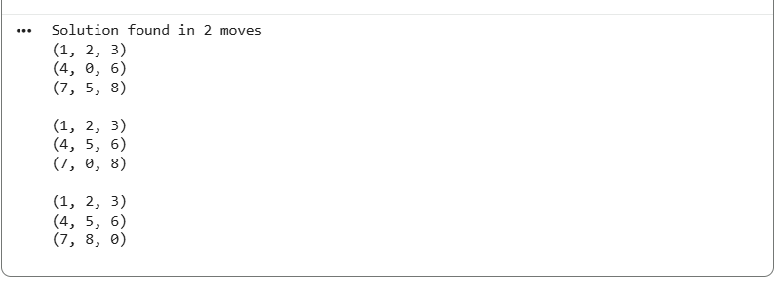
Result: Thus, the Python program to solve the 8-puzzle problem using the A* search algorithm was executed successfully.

